23.23: a)
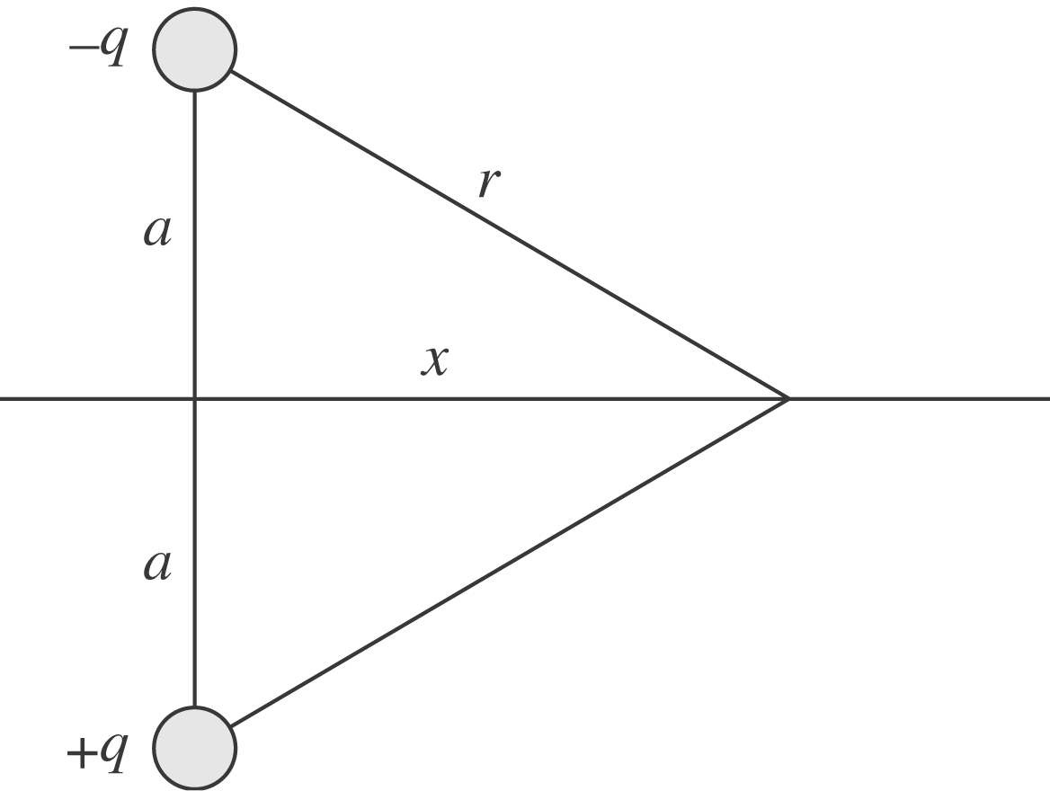
b) 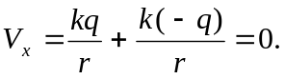
c) The potential along the x-axis is always zero, so a graph would be flat.
d) If the two charges are interchanged, then the results of (b) and (c) still hold. The potential is zero

